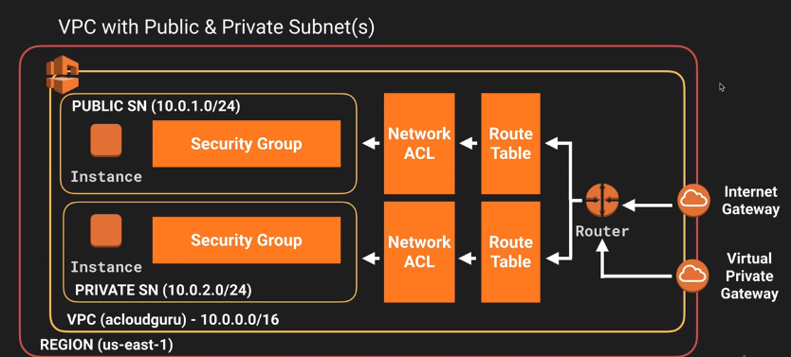

Create VPC as below:

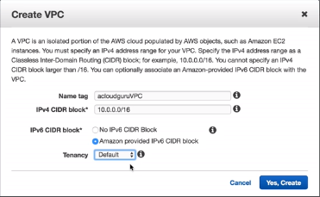

Route tables,NACLS , security grps are created by default after creation of vpc

After this Create Subnet:

0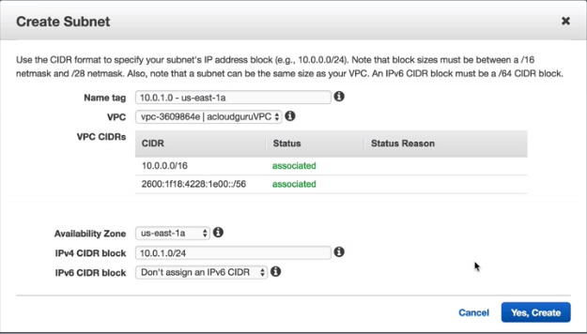

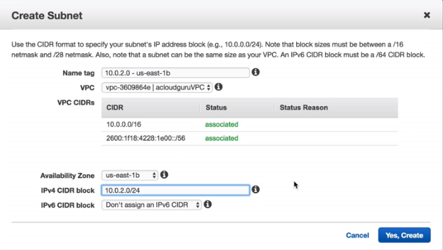

After this create Internet gateway “MyIGW”and attach your VPC

The go to root tables, create root table

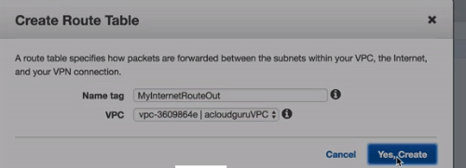

Then we need to enable internet access.

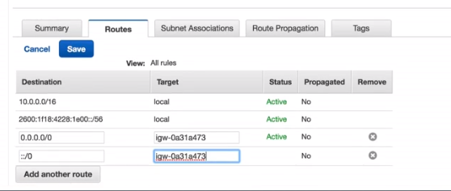

After this subnet association

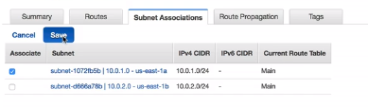

After this go to Subnets and make your public subnet as auto assign public ip

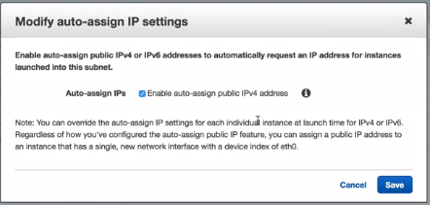

After this we launch public subnet and private subnet. After this go the subnet window and make 10.0.1.0 –us east-1a as public subnet

After this launch EC2 instances, in configuration instance tab, Choose ypur VPC in network, choose your public subnet.

After this create new security group”Web-DMZ”, ssh and http. Choose new key pair

Launch second instance with 10.0.2.0 and select default security grp and choose new key pair.

After this connect to public machine and try to check if it is internet connected.

=====================================================================

After this rename your private instance to MY-SQL, and go to security grps and create new security grp named”MyRDS-SG”, add yor VPC.

Add SSH, MySQL/Aurora, https, http, all ICMP ipv4. Add for all protocols add cidr as 10.0.1.0/24

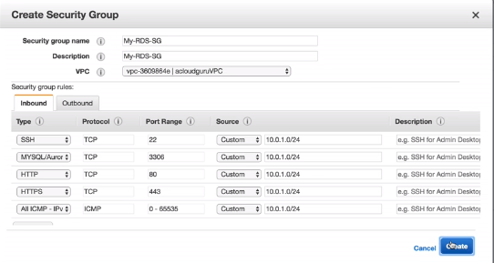

After this associate it to private instance and ping private ip from public console

After this test connectivity.

[ec2-user@ip-10-0-1-167 ~]$ vi mykey.ppk

[ec2-user@ip-10-0-1-167 ~]$ chmod 400 mykey.ppk

[ec2-user@ip-10-0-1-167 ~]$ ssh ec2-user@<private_ip_address> -i mykey.ppk

After connectivity, elevate privileges and check for command yum updaye -y

============================================================================

After this create NAT instance(select it form community AMIs), for public instance(10.0.1.0 –us-east-1a) and also selecting your own VPC, security grp will be MyWEBDMZ(http, https and ssh). Download new key.

After this go to your NAT instance and in actions>>networking>>change source and destination checks (disable)

After goto route tables, add route by selecting default root table created by NAT:

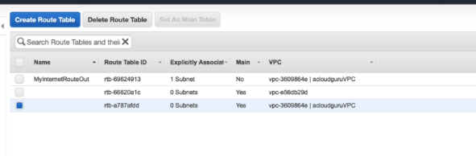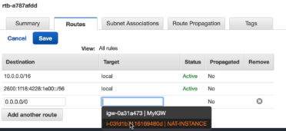

After this connect to private ip from public console with command

ssh ec2-user@10.0.2.127 -i mykey.ppk

and then run sudo su and yum update –y

==============================================